EMBRACING ANXIETY
with Molly Tipping
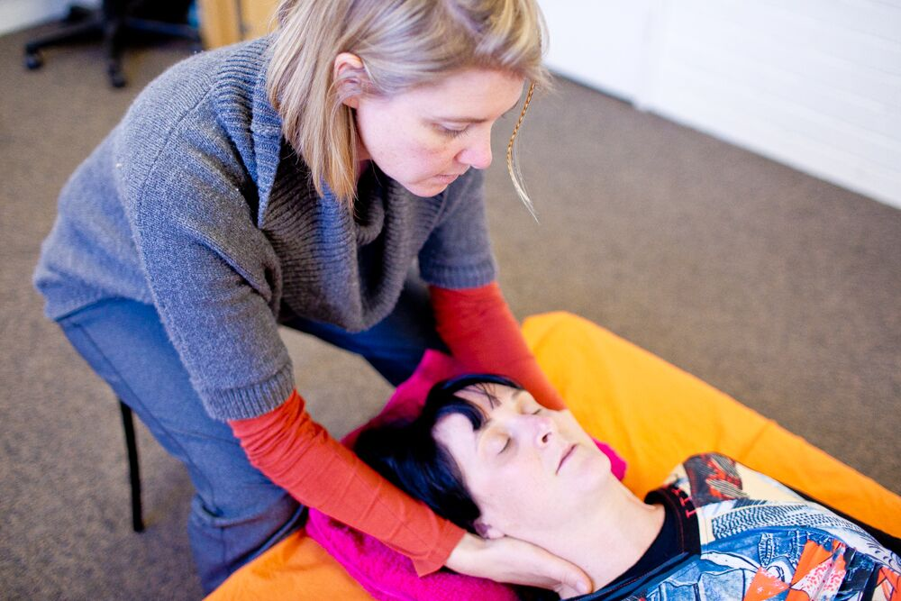

NOVEMBER 11 and 12, 2017
Venue and Cost : Mindful Action Studio, North Sydney
Feldenkrais Practitioners are invaluable as complimentary therapist for people experiencing anxiety. In this 2 day workshop Molly Tipping will share case studies and key ATMs and FI’s that form the foundation of her work with anxiety, while cultivating a reflective learning environment to allow participants to learn from, trust and be guided by their own anxiety and insight. This workshop offers theory, ATM and FI templates, and self-use tools to give you the confidence to embrace anxiety.

AIMS OF THE WORKSHOP

- Consider Feldenkrais’ writings, current literature and best practice for working with anxiety
- Explore your own anxiety response and learn tools to be present with another persons anxiety
- Recognize anxiety in your clients and learn how to address it overtly and subtly
- Interview techniques, FI Lessons and embodiment tools for private clients
- Teaching tips and lesson choices to address anxiety in ATM classes
Molly Tipping is a Certified Feldenkrais Practitioner, Pilates Instructor and has a Bachelor or Arts in Dance. She has been working in the movement field for 19 years and has been teaching ATM’s since 2008 and FI’s 2011. She currently runs a private practice in West Perth assisting clients with anxiety, injury recovery, chronic pain, learning difficulties and dance technique. Molly also lectures in Alignment, Kinesiology and Performance Psychology at the West Australian Academy of Performing Arts in the Dance, Voice and Acting departments. Molly has also taught professional development (PD) workshops for The Pilates Method Association (APMA), The Royal Academy of Dance (RAD) and The Feldenkrais Guild of WA and NSW and is the co-producer, with Brigit Cosgrove, of Move Over Anxiety, a Feldenkrais audio program currently on sale in Australia and The United States.

